Gotham Online Credit Card Payment Instructions with Screenshots

Step 1. Click on your individual group’s pay now link -you will see the window below (please be signed in to your Gotham Website profile.)
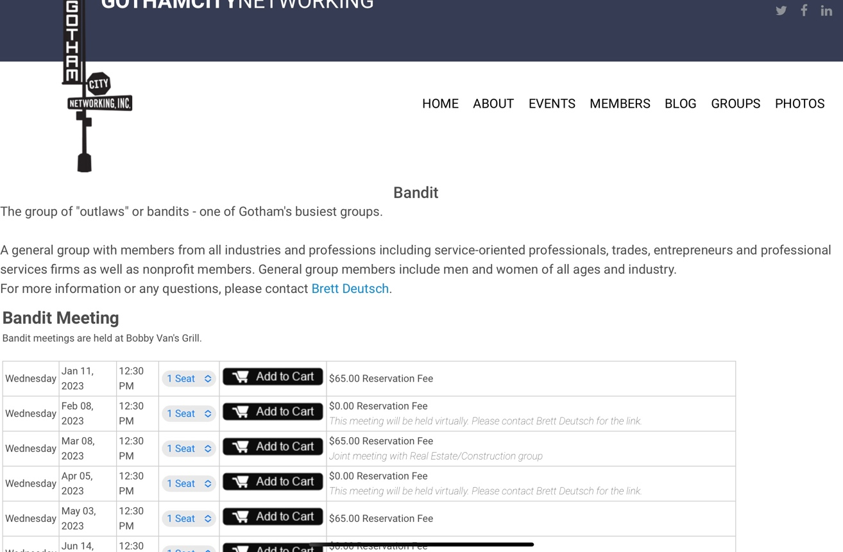

Step 2. Scroll down past meeting guest fees to the 2023 Dues area & Click Add to Cart.
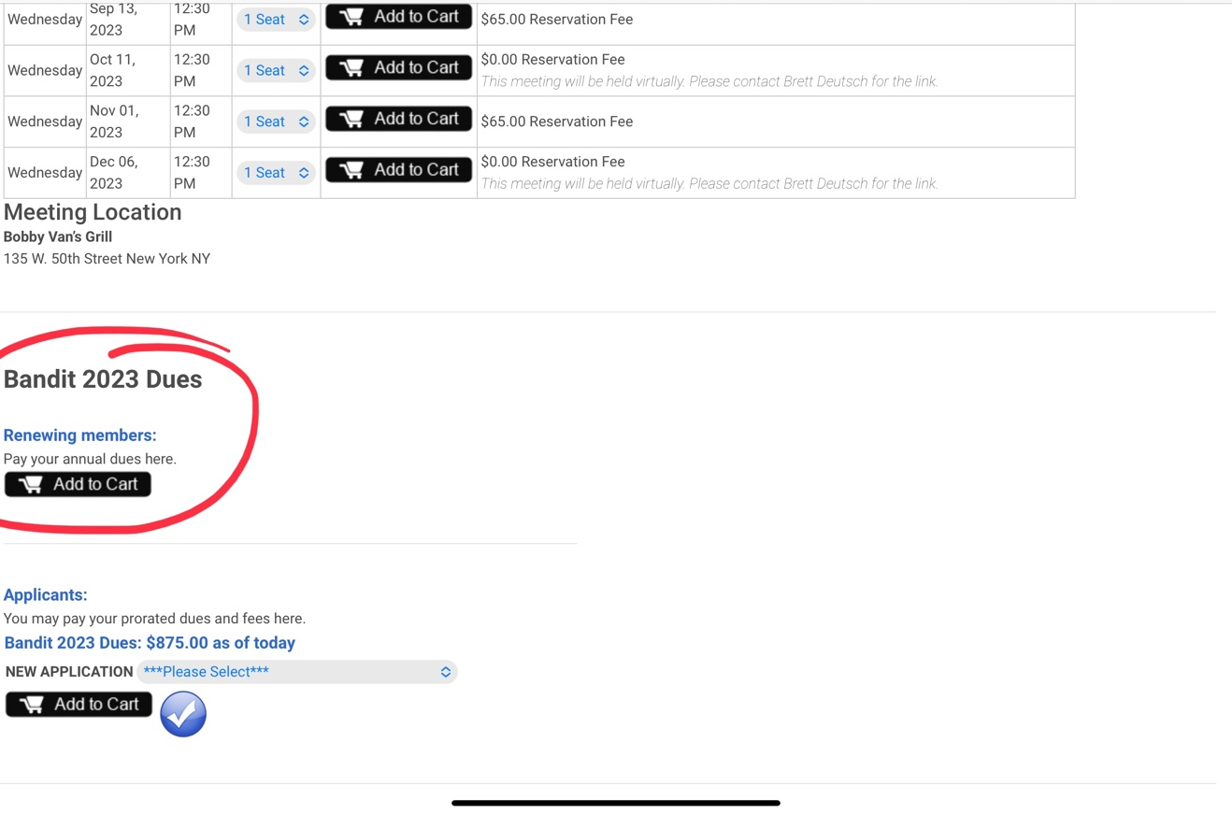

Step 3. Find View Cart & click.
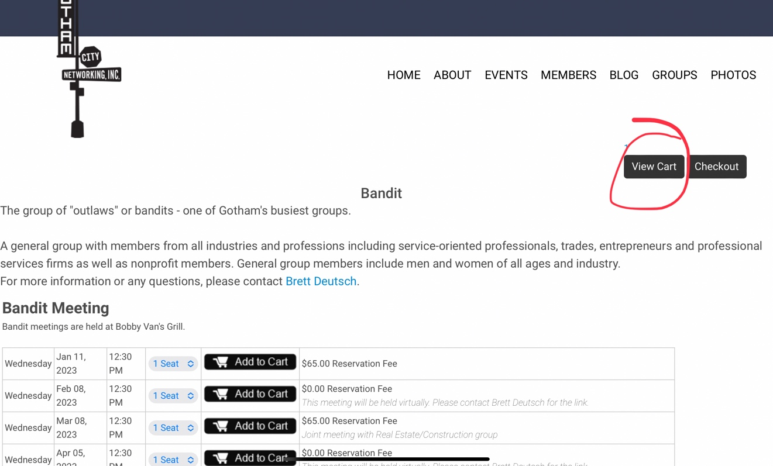

Step 4. Once you verify the amount is correct, Click Checkout.
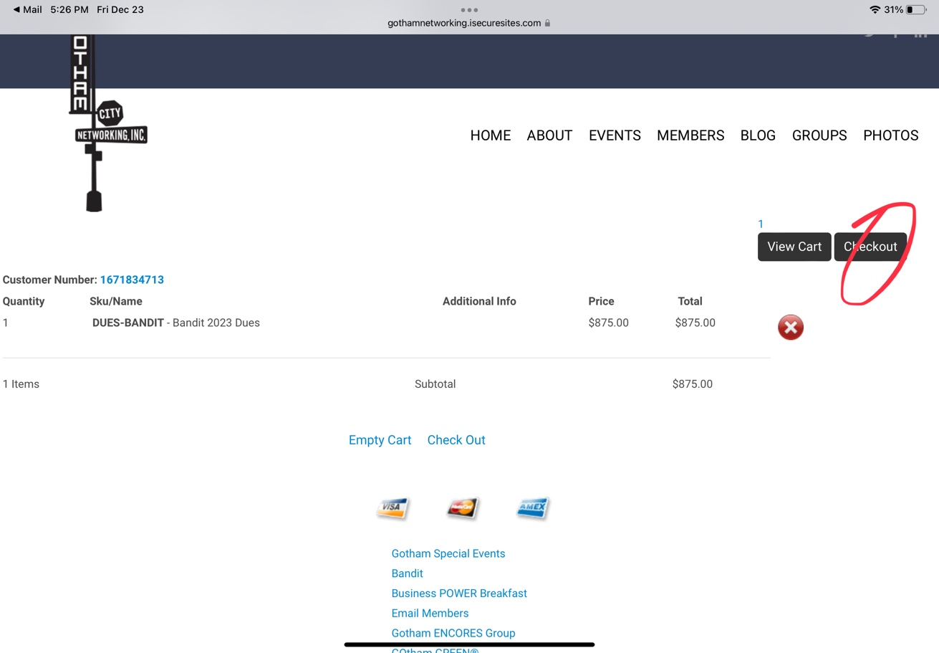

Step 5. Enter all information carefully in the next set of boxes. Please be sure to enter the address that matches your credit card statement address (if you do NOT your transaction will be declined).
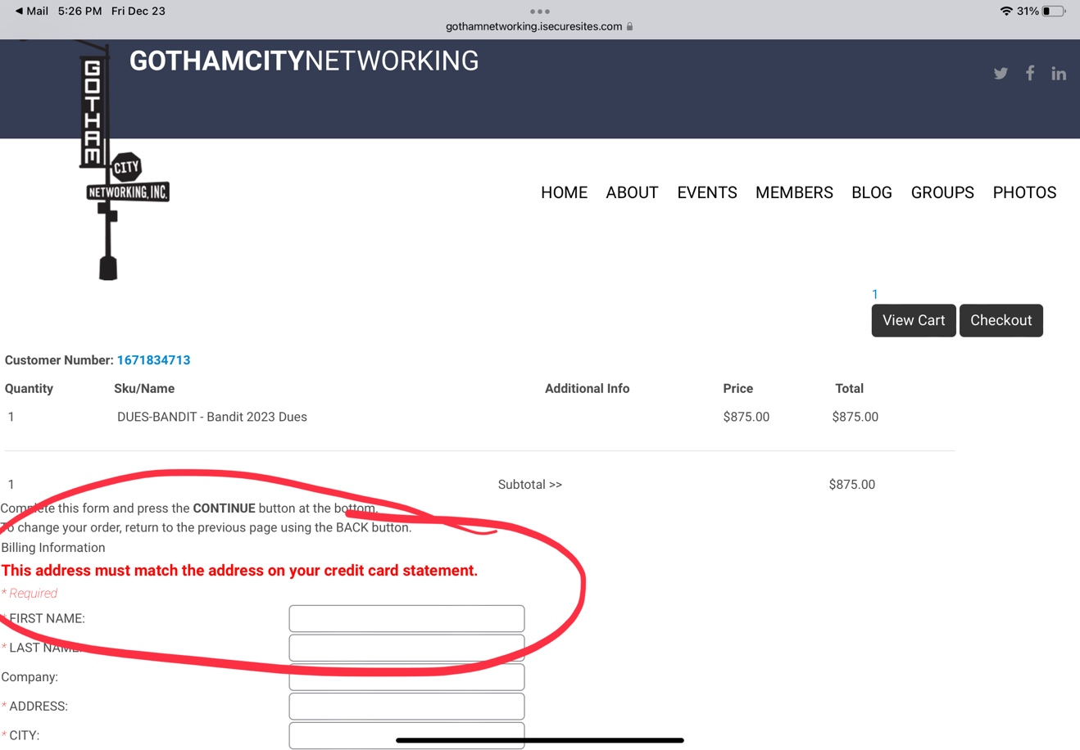

Step 6. Click Continue. Congratulations, you’ve completed the process!
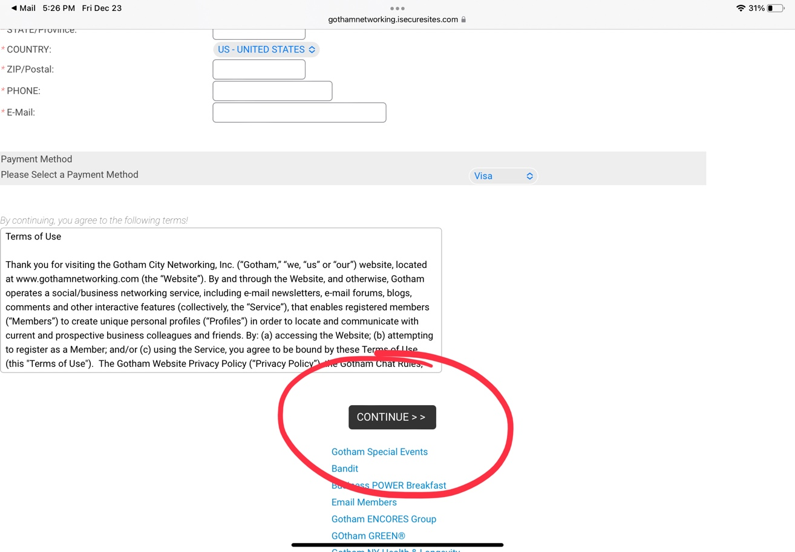

PAY NOW LINKS
Bandit: https://gothamnetworking.isecuresites.com/group/Bandit
Bus Breakfast: https://gothamnetworking.isecuresites.com/group/Gotham-Business-POWER-Breakfast
Encores: https://gothamnetworking.isecuresites.com/group/Encores
Email: https://gothamnetworking.isecuresites.com/group/Email-Members
Green: https://gothamnetworking.isecuresites.com/group/GOtham-GREEN
LI Dinner: https://gothamnetworking.isecuresites.com/group/Long-Island-Dinner
NY Health: https://gothamnetworking.isecuresites.com/group/NYHealthandLongevity
Princeton: https://gothamnetworking.isecuresites.com/group/Princeton-NJ
Queens: https://gothamnetworking.isecuresites.com/group/Queens
RE/Const: https://gothamnetworking.isecuresites.com/group/RE-Constr (new link as of 11.28.22)
Virtual: https://gothamnetworking.isecuresites.com/group/Gotham-Virtual
Westchester: https://gothamnetworking.isecuresites.com/group/Westchester
Young Pros: https://gothamnetworking.isecuresites.com/group/liyoungpros
LI Legal: https://gothamnetworking.isecuresites.com/group/LI-Legal
LI Women: https://gothamnetworking.isecuresites.com/group/Women-Long-Island
Long Island: https://gothamnetworking.isecuresites.com/group/Long-Island
NY Legal: https://gothamnetworking.isecuresites.com/group/NY-Legal

