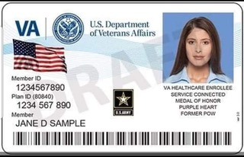

Register Here for the
New VA ID Card

