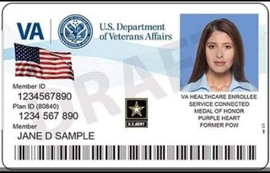

**Register Here for the**

**New VA ID Card**