How to Become Above Average

By
Atlas Rowe
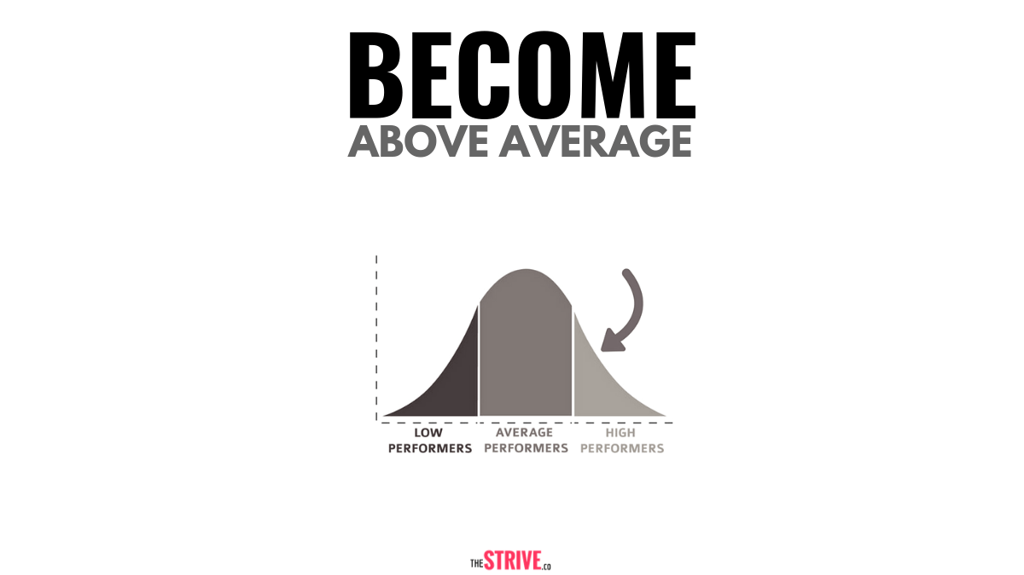
Are you part of the cult of the average? If you’re not sure, you may want to give this piece a few minutes of your time.

TODAY YOU WILL BECOME ABOVE AVERAGE

I want to talk about an extremely simple way that any person can make marked progress in just about any area of their lives.
What I am going to share with you today is a concept that anyone listening in with an eager ear to make some kind of adjustment, any kind of adjustment in their lives, can implement with relative ease, and start seeing serious results, and in short order.
Now one of my favorite American poets, Henry Wadsworth Longfellow once stated that “In character, in manner, in style, in all things, the supreme excellence is simplicity.”
So, with that being said… I must advise you, that what I am sharing with you today is going to be a VERY simple concept or approach that can be applied to multiple aspects of our lives. It’s an extremely simple approach to attacking situations,
However; regardless of its simplitcity….it is an approach that can make all the difference between you being average, and you becoming above average in every aspect of your life. Now before I go into this concept, I must say… I don’t have all the answers…
If’ you’ve been listening to the show for a while now, you probably already know that by now….
BUT, I am fervently searching for the answers, just like you. I am striving every day, to become more of my best. I want to become my best, so I may give you the best.
I too, am in the process of forging greatness!
Why? Because I, much like you, want the most out of this life…. I want to leave a legacy, I want to become more, I want to experience more, have more, give more….
And I am a firm believer, that if we want to have more, we must become more.

The Key to Become Above Average
Alright… so with that being said… you are probably ready, already…to learn of this concept….
So here we go, the acronym for the concept is F.I.L.O. But to make it cool, if not cooler than YOLO, were gonna call it FILO… yeah buddy!!!
So, what does FILO stand for? Drum roll….
Here it is… Wait for it… First In, Last Out.
Yes, that’s it…. First in, Last Out.
If you apply a ‘First in, Last Out’ mentality to all you do… there really is no way you can remain a below average or average person. It will be virtually impossible to be average, because average lives in between the first in and the last out.
So here is how it works.
If you want to see marked progress in your profession……everyday, starting tomorrow… be the First in, and the last one out. The first person to get to work, and the last person to leave. Be the first one to show up to meetings… and the last one to leave… Be the first one to volunteer for a challenging project… and the last one to push it away.
If you do this, your boss(es) will take notice of your dedication, your peers will notice your commitment to the organization, and all areas of your contributions to the company will increase. And you know what that means. That’s right, cha-ching!! Raises, promotions, RESPECT!!! Go get it… First in Last Out!!
If you want to start seeing some crazy serious results in the gym… find a way to be the person who is first in, and the last one out. Obviously, you don’t want to live in the gym… but if there is someone who’s physique you would like yours to rival…then you need to find a way to be in the gym longer than them…doing exactly what they are doing and more. Be the first in and the last out!
In relation to competitive sports… if your competition is another teammate who’s vying for a position you are aiming for as well… but they keep getting to the gym before you …and they always seem to be leaving after you as well… watch out… because you will be out worked, and you will lose that coveted spot.
So, if you want the top spot (not the 2nd, 3rd, 4th, or the average spot… stop messing around already….and start being the first in, and the last out!!!
If you want to beat the other team… you better find out when the other teams are practicing, for how long, and what type of training they do as well…….
Then you must do what it takes to apply the F.I.L.O approach… if you don’t, you will lose. Maybe not right away… but you will, eventually! Avoid being average… average does not equal victory…. don’t set yourself up to lose my friends…. be first in, last out!
For you entrepreneurs out there…. Are you spending enough time creating, researching, taking action to create massive value for your customers, and more value than your competition can provide? Are you striving early in the am, and late at night, to make sure that what you are working on is valuable to the marketplace? Are you applying the First In Last Out approach to your business?
If you don’t want to give the competition an easy way to seize your market position, strive to apply the First In, Last Out approach!

F.I.L.O. in the Real World
Now here is a bit of trivia for you…Did you know:
- Mark Cuban, the Shark Tank investor and Owner of the Dallas Mavericks didn’t take a vacation for 7 years while starting his first business…. Did you know he would routinely stay up till 2 am researching his craft and the competition? Now he’s a billionaire! First in Last Out!
- Facebook’s COO, Sheryl Sandberg leaves work every day at 5:30 like an average employee, but once those kids are tucked in and asleep…. She’s back at it and in Strive Mode…taking care business throughout the night. First in, Last Out!
- Amazon’s Founder, Jeff Bezos was known for putting in 12-hour days, seven days a week, and being up until 3 a.m. to get books shipped during the first few years of Amazon…. And now he’s one of the richest people in the world!
- Venus and Serena Williams, at the young age of 7 and 8, would be up at 6:00 am every morning…. They would get up, 6 o’clock in the morning, go to the tennis court and practice before school. Then, once school was out, they were always back at if for another practice session. First in, Last out!
- The PayPal co-founder and SpaceX and Tesla CEO, Elon Musk… lives and breathes the F.I.L.O concept, and you have to, to accomplish all that he has. Magazine published an article in the past that quoted him saying… “If other people are putting in 40-hour workweeks and you’re putting in 100-hour workweeks, then, even if you’re doing the same thing, you know that you will achieve in four months what it takes them a year to achieve.” Love it… Now that is First in, Last Out to its core!

Now the few examples I just mentioned are obviously Titans… Icons, Legends…. But they’ve left us some obvious traces of what has helped them become so much more than average!

STOP BEING AN AVERAGE JOE
So now you know what it takes. You now have a new approach, a new mindset hack that you can use to help you step up, over, and out of average.
If you haven’t already been applying such an approach to your life… just Imagine what kind of results you are going to start to experience when you begin applying this FILO mode of being.
I don’t know about you guys… but I am done being average.
I know I can do more and become more in this life, and I know the same is true for you, without a doubt! So, if up until this point you feel like you’ve been on an average path in your life, maybe now is the time…

To Strive, Yes! To Strive to be First in, Last Out!
I am excited for you my friends…. If I hope you accept the challenge!
So, what are you going to do with it?

STRIVE

