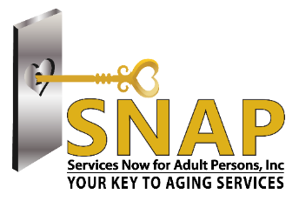
80-45 Winchester Boulevard, Building # 4, CBU #29
Queens Village, New York 11427
T: (718) 454-2100 F: (718) 740-4999
E: info@snapqueens.org W: www.snapqueens.org

BOARD OF DIRECTORS

COREY BEARAK, ESQ.
CHAIR

FLORENCE KATZ, MSW
VICE CHAIR

SEAN R. SINGH
TREASURER

SUSAN SEINFELD, MSW
RECORDING SECRETARY

JACQUELINE BOYCE
DILIP CHAUHAN
SUSAN COHEN
SHEETAL DESAI, DPT
HIMANSHU PANDYA, MD
RENEE’ RICHTER
LINA SCACCO
RONALD SCHWARTZ, ESQ.
DAVID STEIN, CFE
MINDY STERN, SPHR

~
PAOLA MICELI, MPA
CEO/PRESIDENT

MARIAN LEWEK, LMSW
CHIEF OPERATING OFFICER

Dear Community Member,

Services Now for Adult Persons, Inc. (SNAP) recognizes the importance of networking amongst local businesses and the community. The expansion of resources to better meet the needs of older adults and their caregivers, as well as, supporting local businesses is what our Community Business Partnership is all about. Please join us as our Community Business Partnership once again participates in SNAP’s Annual Caregivers Conference which will be held on Thursday November 21, 2019 from 9:00 AM to 12:30 PM at Antuns banquet hall in Queens Village, New York.
We would like to take this opportunity to cordially invite you to support us in expanding both our network and yours. Please reserve a table to display informational publications, as well as a place for representatives to answer questions about your product and/or services.
For your convenience, the bottom of this letter may be used as a response form. You may return it via fax or email to expedite your response which will enable us to plan this event most efficiently.
For further information please contact Mindy Lesser at (718) 454-2100 Ext: 116 or mlesser@snapqueens.org.
Sincerely,
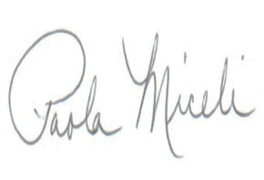

Paola Miceli
CEO/President

Name of Organization:_______________________________

Telephone:________________________________________ Fax:____________

Email Address:______________________________@ _________________

We would kindly like to reserve a table for a donation of $100.00
Payment accepted via check or money order made out to:
Services Now for Adult Persons, Inc.

