
Presents
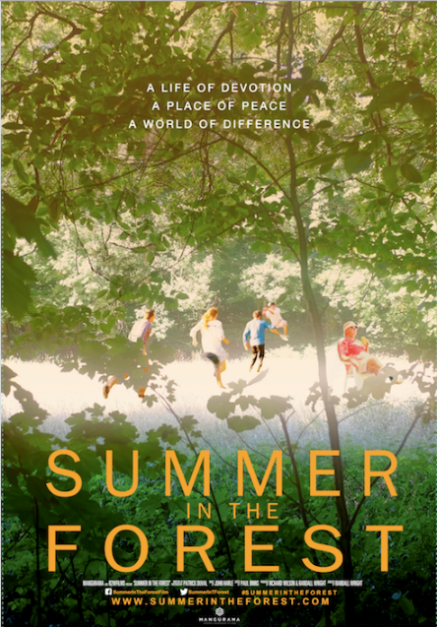
SUMMER IN THE FOREST

Release Date: NY: March 23rd – Village East Cinemas
LA: April 6th
Directed by: Randall Wright
Producers: Richard Wilson, Randall Wright
Director of Photography: Patrick Duval
Film Editor: Paul Binns
Synopsis: Like countless others Philippe, Michel, Andre and Patrick were labeled 'idiots', locked away and forgotten in violent asylums, until the 1960s, when the young philosopher Jean Vanier took a stand and secured their release - the first time in history that anyone had beaten the system. Together they created L'Arche, a commune at the edge of a beautiful forest near Paris and a quiet revolution was born.
Now in his 80s and still at L'Arche, Jean has discovered something that most of us have forgotten - what it is to be human, to be foolish, and to be happy.

SUMMER IN THE FOREST invites us to abandon the rat race and forge new friendships. Amid the ancient trees, Philippe, Patrick, Jean and the others welcome us into their lives. If there are rules to break, they will be broken and if there is a truth to be told, they will tell it. Michel wants to share with us his war torn past, Andre is desperate for a date, and young David will prove himself a hero in the fight against the forces of evil.

Trailer:
https://www.youtube.com/watch?v=wLf1rx2RPrE

For Download:
https://www.dropbox.com/s/t7ip7917fyq66s5/SummerInTheForest%20TRAILER%20FINAL.mp4?dl=0

Film Website:
http://www.summerintheforest.com/

For more information, please contact Scott Feinstein (Scott.Feinstein@42West.net) or Jordan VanBrink (Jordan.VanBrink@42west.net)

