New York City SHRM’s
Organizational Development & Change Management SIG Presents:

PITCH PERFECT: How to Pitch Strategically and Purposefully to Cut Through Red Tape and Get What You Really Want

In today's increasingly changing and complex work environment it's ever more important to know your professional "brand," and to be able to articulate your unique selling points. Whether you aspire to land your 'dream job' or to take that next step in your career, our presenters will show you how to clearly distinguish yourself from your peers and competitors to achieve your professional goals and the outcomes you desire most.

This presentation will teach you how to:
- Deliver a powerful and persuasive elevator pitch
- Create a slam-dunk pitchbook that is sure to help you land your "dream job"
- Build relationships and keep your network active through regular and effective follow-up
- Communicate your way up the corporate ladder with clarity and confidence

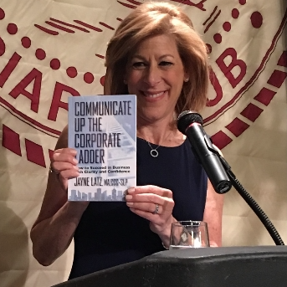

Susan Rosengarten Jayne Latz
Talent Associate at Nomura President and Founder of
Corporate Speech Solutions, LLC
Event details:
Date: Tuesday February 6, 2018
Time: Arrival: 6:00pm
Presentation: 6:30-8:30pm
Location: New York Institute of Technology (NYIT) 16 West 61st Street – 11th Floor Auditorium

No charge for New York City SHRM members. $20 for non-members. *Photo identification is required to enter the building.

ALL ATTENDEES MUST PRE_REGISTER ONLINE PRIOR TO THIS EVENT
If you have questions, contact:
Susan Rosengarten (Sue.Rosengarten@gmail.com) Jayne Latz (Jayne@corporatespeechsolutions.com)

