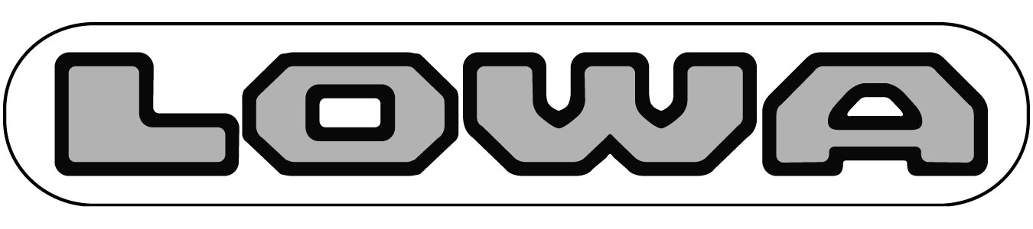

LOWA Boots, L.L.C.
86 Viaduct Rd • Stamford, CT 06907 • USA
toll free: 888-335-LOWA • tel: 203-353-0116
fax: 203-353-0311 • www.lowaboots.com

LOWA Boots, LLC performs the US sales, marketing & distribution for LOWA Sportschuhe GMbh based in Jetzendorf, Germany. We import outdoor boots & shoes from Germany and ship wholesale to several hundred customers throughout the US ranging from small outdoor & shoe shops to multi store chain shops and large national accounts.

Below is a general job description for the Accounts Receivable & Customer Operations Position:
- Post customer payments by recording cash, checks, ACH transfers and credit card transactions.
- Maintain records of customer invoices, debits and credits.
- Verify validity of account discrepancies by obtaining and investigating information from sales, customer service and customers.
- Resolve invalid or unauthorized deductions & chargebacks by following procedures
- Resolve collections by examining customer payment plans, payment history, credit line; coordinating contact with outside credit manager
- Regularly contact customers by telephone or email to collect past due funds.
- Set up & maintain dealer records & routing instructions on software system
- Maintain website dealer listings
- Annual year-end file maintenance
- Maintain dealer applications & related credit information
- Maintain dealer payment files
- Protect organization’s value by keeping information confidential.
- Update job knowledge by participating in educational opportunities.
- Answer phones when customer service reps aren’t available.
- Special projects
- Attention to detail, follow up & a high degree of organization mandatory

A minimum of 2 years in a previous Accounts Receivable position is required. Ideally we would like someone with at least an Associate’s degree. The ideal candidate needs to be able to speak and write English well as email correspondence is an important part of the job. Must be able to work well with others in a small business team oriented environment.

Skills/Qualifications: Organization, Accounting, Data Entry Skills, General Math skills, Thoroughness, Verbal Communication
Computer Skills: Excel, MS Word, Outlook, (Footwork’s would be a huge plus!)

Hours are 8:30-5:00 M-F. After 90 days, eligible for Health/Dental/Vision insurance; company pays 80%. Eligible for Matching (up to 6%) 401K plan after 6 months, life insurance with option to purchase supplemental policy after 90 days, eligible for Long term disability, AD & D and more life insurance after 90 days and 2 free pairs of LOWA’s every year.

Please send your resume & cover letter along with 3 references to jobs@lowa.net.

